**Tic Tac Toe**

**Build a "Tic-Tac-Toe" game that allows two players to take turns and determine the winner.**

**Players**:  
Two players take turns, one playing with "X" and the other with "O".

**Board**:  
The game is played on a 3x3 grid, making up 9 cells. Each cell can be marked with either an "X" or an "O".

**Turns**:  
Players alternate their turns by selecting an empty cell to place their respective mark (either "X" or "O").

**Winning Conditions**:  
A player wins if they are able to place three of their marks in:

* A horizontal line (any row)
* A vertical line (any column)
* A diagonal line (either of the two diagonals)

**Draw Condition**:  
If all nine cells are filled and neither player has aligned three of their marks, the game ends in a draw.

**Restarting the Game**:  
After a win or draw, the game can be restarted, resetting the grid and allowing the players to start over.

1. **Output Screenshot**

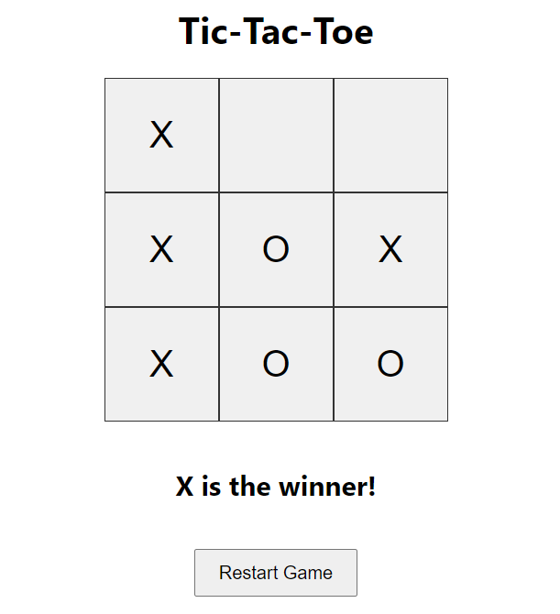

1. **Widget Used In Task**

* Button Widget represents the 3x3 grid cells where players make their moves
* Button Widget Used for Restart.
* Text View Used to display Winner.